Mental Health Response Advisory Committee (MHRAC)
Meeting Minutes
July 19, 2022
Via Zoom

Board Members in Attendance
Max Kauffman Disability Right of New Mexico
Laura Nguyen Albuquerque Ambulance
Matt Dietzel APD Crisis Intervention Division
Paula Burton NAMI Peer Representative
Rob Nelson APD/CIU/C.O.A.S.T
Emily Jaramillo Albuquerque Fire Department
Coty Maxwell Crisis Intervention Division
Mariela Ruiz-Angel Albuquerque Community Safety
Mary Perez UNM Psychiatry & Behavioral Sciences
Nils Rosenbaum APD Behavioral Science Services
David Ley New Mexico Solutions
Gilbert Ramirez CABQ-Dept. of Family & Comm. Services
Wendy Linebrink-Allison New Mexico Crisis Line
Betty Whiton NAMI
Robert Salazar NAMI Peer Representative

Introduction to MHRAC
The Mental Health Response Advisory Committee (MHRAC) was created by the Court Approved Settlement Agreement (CASA). We’ve been around since day one and have a focus on three areas, resources, and resources being available to access different things within the city that APD and first responders can use as it impacts homelessness and mental health issues. We are also involved in training and policy; training is one of those things we made a tremendous impact on. As far as the training that is offered. Policies are one of those things where the MHRAC is involved with assisting in writing and approving and recommending policy as it relates again to the narrow focus; we think narrow, but sometimes it gets pretty wide focused on how law enforcement interacts with those experiencing homelessness and those experiencing a mental health crisis.

Roll Call, Max Kauffman
Fifteen of the Board Members were present (names listed above)

Welcome first-time guests
No First Guest

Approval of meeting minutes
1st Motion – Paula Burton
2nd Motion – Rob Nelson
Minutes from the June meeting were approved as is

Public Comment (Two minutes per person)
Max
Last Friday Disability Rights of New Mexico hosted a Symposium. We along with the city of Las Vegas, NM were invited by the mayor to speak on the community’s response to those with mental illness. I got a chance to talk to their mayor and law enforcement chief about MHRAC. It seems like they are inspired to create their own MHRAC

Mark Le Clair
- We started handing out responder bags for autism to our eCIT officers from Elevate the Spectrum, a non-profit organization.
- We are also working on getting a connection with the VA Hospital. We often encounter veterans in our line of work and I’m trying to build that connection with them.

Lt. Gonzales
I would like to recognize my Home Visit Team and my Clinicians, Mike and Megan, and COAST. We were on a call a couple of weeks ago; it was one of our consumers that Detective Jeff Jones has been working with for a long time. There were about 16 shots fired from this subject’s house. Southeast Area Command officers set up a perimeter on his house and he was barricaded inside the house with a gun and his girlfriend is crucial in the house. My whole team went out; it was essentially about a 12-hour call. The girlfriend and the grandma ended up coming out. After 8 hours he fired a shot at us but my team remained calm. Rio Rancho SWAT ended up deploying and helping us out as well; he fired a couple of shots at them. He ended up coming out and they got him into custody without hurting him. It was an emotional and scary event but my team just worked so well and I couldn’t be more proud of them for the long day, the de-escalation, the patients, and the good attitude.

The 988 Suicide and Crisis Lifeline Update, Wendy Linebrink-Allison
The 988 Suicide and Crisis Lifeline is now available for all to access nationwide. This is a milestone moment in this country’s history for suicide prevention, crisis, and mental health services everywhere. The Lifeline provides 24/7, free and confidential support for people in distress, prevention and crisis resources for you or your loved ones, and best practices for professionals.
A behavioral health crisis needs a behavioral health response. 988 was established to improve access to crisis services in a way that meets our country’s growing crisis behavioral health care needs. 988 provides easier access to related behavioral health crisis resources, which are distinct from 911 (where the focus is on dispatching Emergency Medical Services, fire, and police as needed).
- 988 provides a reliable, easy-to-remember three-digit code that ensures everyone, everywhere in the United States, has access to high-quality mental and behavioral health crisis support whenever they should need it.
- 988 is a new, free, and easy-to-remember nationwide helpline for emotional, mental, or substance use crises. It’s one part of a larger initiative to build out a behavioral health infrastructure for people in distress to have “someone to call, someone to come to you, and somewhere to go".
- 988 calls, texts, and chats are answered by trained, compassionate behavioral health professionals who know community mental health and substance use resources. They will listen, offer support and work together with the caller to develop a plan for safety and recovery.
- 988 can open the door for people to seek mental well-being or substance use help while sending the message that healing, hope, and help are happening every day.
The 988 Suicide & Crisis Lifeline has arrived in New Mexico. And there is a tremendous need given that:
- In 2020, the U.S. had one death by suicide every 11 minutes.
- New Mexico has the 4th highest rate of deaths by suicide in the U.S.
- For people ages 10–34, suicide is a leading cause of death.
- From April 2020 through April 2021, over 100,000 people died from drug overdoses nationwide.
Behind each of these data points, there are people, families, and communities who have been impacted. Yes, in the face of these urgent realities, there is hope. We can all help prevent suicide.
On July 16, 2022, the 988 dialing code went live. 988 is the new three-digit number to call (multiple languages), text, or chat (English only) that connects people to the existing National Suicide Prevention Lifeline, where compassionate, accessible care and support are available for anyone experiencing mental health-related distress. The chat feature is available through Lifeline’s website. People can use 988 if they are having thoughts of suicide, experiencing mental health or substance use crises, or any other kind of emotional distress. People can also dial 988 if they are worried about a loved one who may need crisis support.
The Lifeline works! Since the Lifeline began in 2005, it has served as an invaluable resource, helping thousands of people overcome suicidal crises or mental health-related distress every day. With the initiation of 988, these life-saving services are even easier to reach.
In preparation for 988, the federal government and partners from across many industries in the public and private sectors have worked together to provide guidance and resources to make it easier to spread the word on this resource. Notably:
- The National Action Alliance for Suicide Prevention and its messaging task force developed the 988 Messaging Framework to provide guidance on developing 988-related messaging. It also discusses the importance of understanding how 988 works locally, following communication best practices and tailoring 988-related messages for specific audiences.
- The Substance Abuse and Mental Health Services Administration (SAMHSA) created a one-stop shop, the 988 Partner Toolkit, at gov/988. The toolkit is intended for SAMHSA’s 988 implementation partners—including crisis call centers, state mental health programs, substance use treatment providers, behavioral health systems, and others—and provides key messages, FAQs, logo, and brand guidelines, and more information about 988. SAMHSA will add social media posts, wallet cards, magnets, and other materials about 988 to the toolkit over time.
- SAMHSA has worked with partners across several critical industries to create a holistic view of readiness for the implementation of 988 for states, territories, tribes, crisis contact centers, public safety answering points (PSAPs), and behavioral health providers. Through these collaborative efforts, SAMHSA created guidance documents (e.g., “playbooks”) for these critical groups to support the implementation of 988.

While this is an exciting time to reimagine how we provide crisis services in the U.S., the full vision of a transformed crisis care system with 988 at its core will not be built overnight. 988 is an important first, but not the final step, in reimagining New Mexico’s behavioral health crisis system to respond to anyone in need. The New Mexico Human Services Department, Behavioral Health Services Division believes New Mexicans deserve to have mental health within reach. Building the Crisis Now Continuum of Care is about meeting people where they’re at when they need it most. Transformation of this scale will take time, and requires resources from federal, state, and local levels to prepare the crisis system to better meet these needs. That is why we must all work together to make it happen. It is important that we speak with one voice about 988 to ensure a clear understanding of what it is and how it works.

Nomination of New Board Members, if any, Rachel/Max
No nominations were made

Albuquerque Community Safety Department update, Mariela Ruiz-Angel

www.cabq.gov/acs/documents/acs-monthly-informational-report-June-2022-condensed

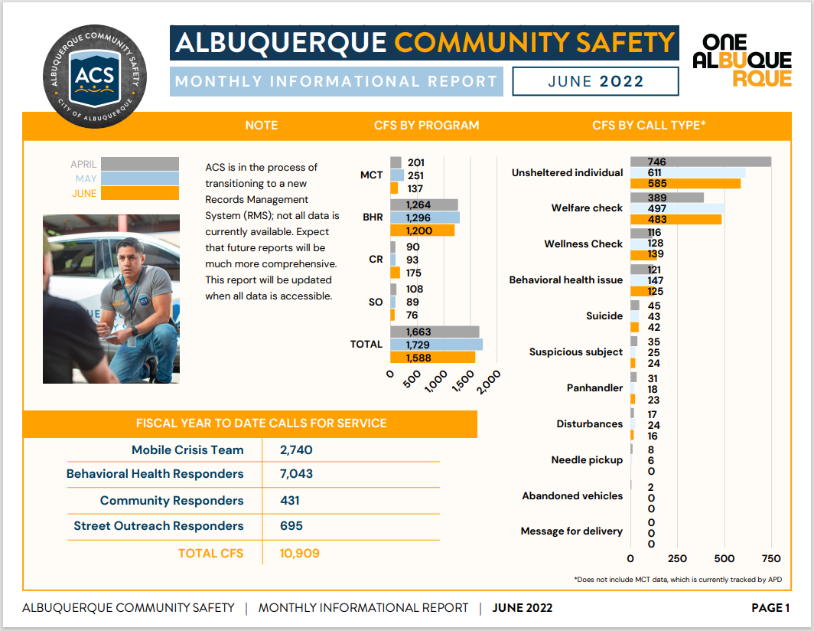

David Ley
Q. What training models are you using around suicidality and would it be helpful if we discuss that at the Training Sub-committee meeting?

Mariela
A. We have a small training piece on suicidality but it is not where I would like it to be. It is not just ideation we are also hitting complete which is really tough on responders.
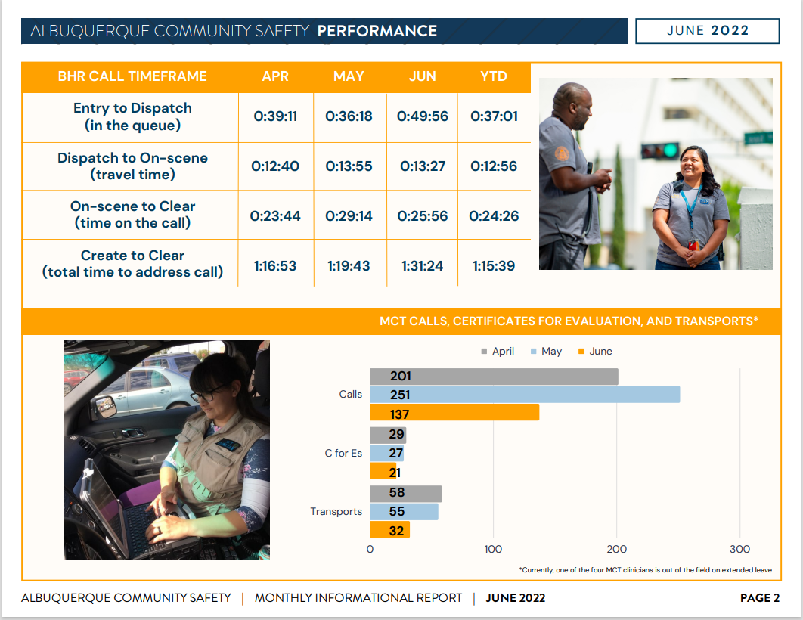
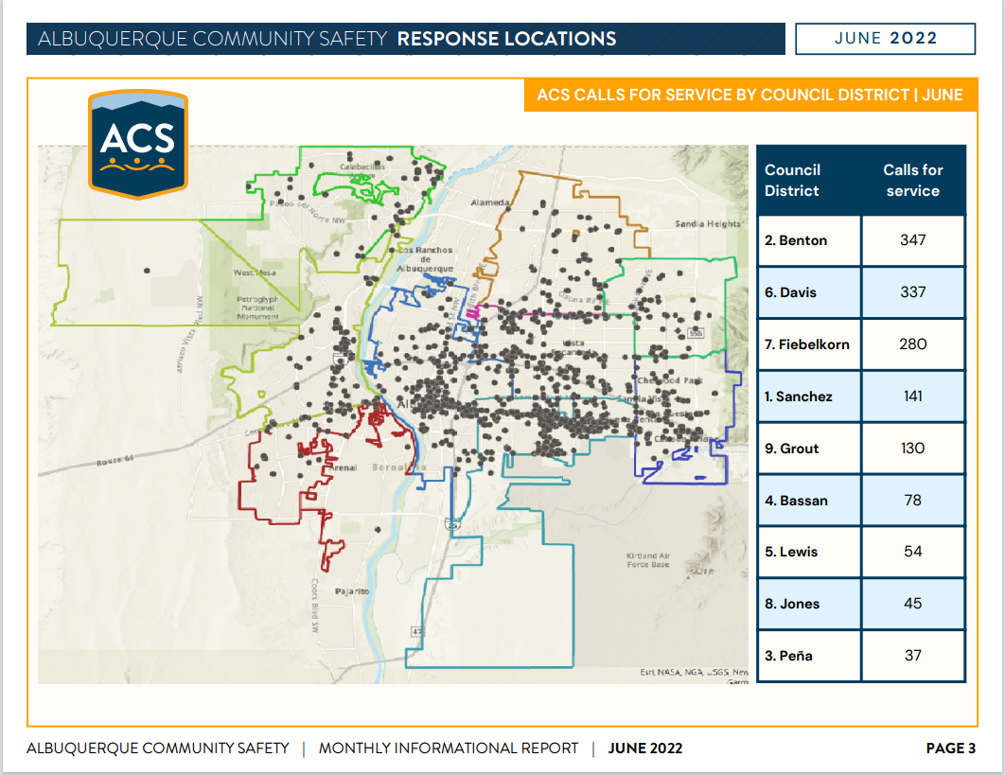
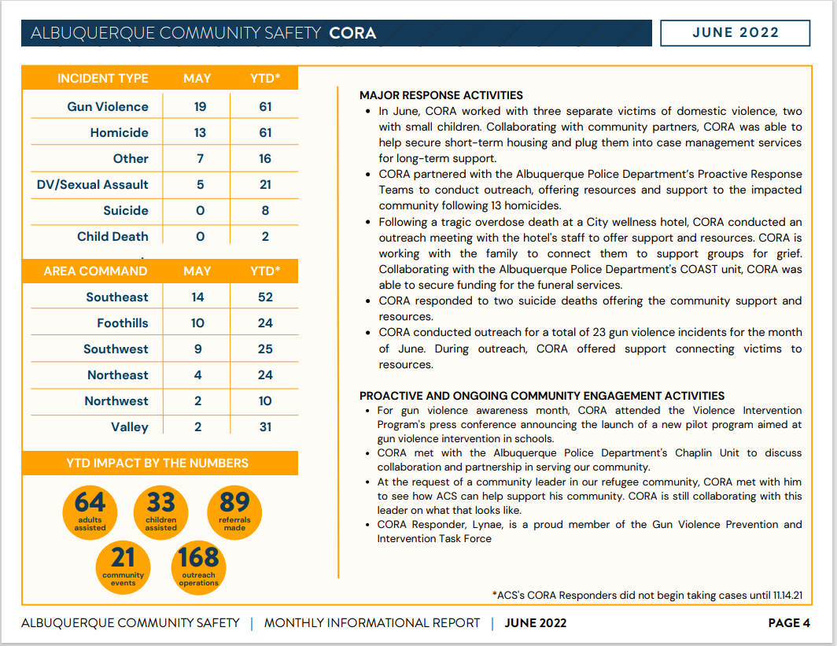
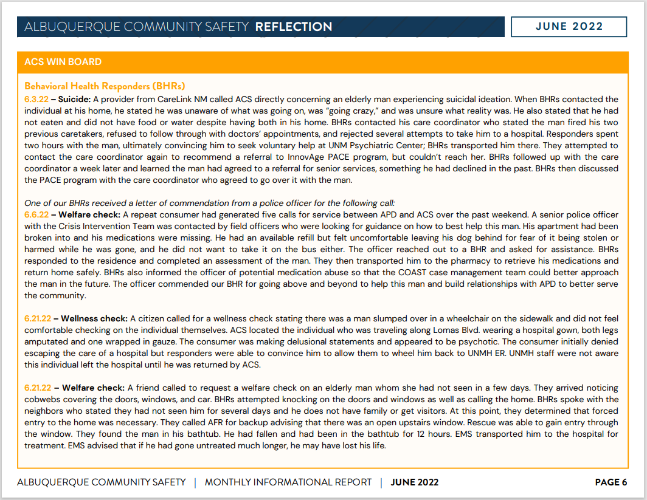
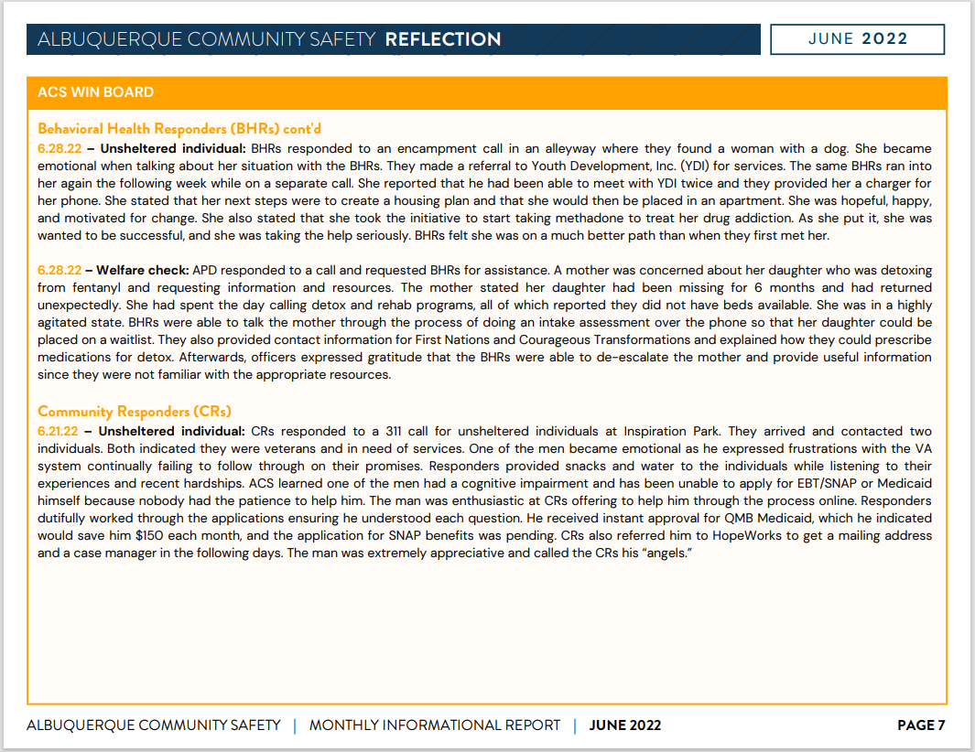

Gibson Health Hub, Family and Community Services, Cristina Parajon
Gilbert
- RFP update:
- We had some responses and a provider was selected
- We now move to contracting and scope negotiation
- Four Major Projects:
- A lot of renovations are taking place, conference rooms are being redone as well as the engagement center
- Gateway Shelter Component should be online early start of the incoming year
- We will have medical respite for folks who are coming out of the hospital and need a place for healing
- We are also looking at medical sobering to be able to put a 23-hour and 59-minute access point for first responders and folks that they find who need medical sobering which would be just a little higher acute care than what you would get at Cares Campus from their social model. We have been working closely with the county around that
- Trauma Recovery Center is not the typical medical Trauma Recovery Center that all are familiar with but it’s one tied to our Violence Intervention Program. These are the folks who have experienced severe trauma in the neighborhood
Max
Q. In coordination with Cares Campus, you mentioned some people may need medical detox rather than social model detox; is there some sort of coordination, like transportation, or a way for them to get to the Gibson Health Hub?
Gilbert
A. Primarily we are going to take calls that are triaged from AFR and First Responders out in the field. And, it could be potentially ACS as well as APD through that triaging because we do not have the exclusion and inclusion criteria for Cares Campus. We have been in constant communication with them as far as how those systems work, so it is a possibility somebody inappropriately might show up at the Cares Campus, hopefully, it's the reverse, that the Medical Sobering might be the appropriate response for them, and as they reach their sobering hours. We can then transfer them to Cares for that lower level social model, or perhaps entry into detox over there as well. We're already having those conversations with the county about how that coordination would work and transportation. There was some budget money allocated for transportation issues for Gateway and Gibson Health Hub; which has already been approved

Max
Q. What are the operating hours? Is it going to be 24/7?

Gilbert
A. Yes, Medical Sobering will be 365 days a year, 24 hours. It is expected that clients will be less than a 24-hour stay; typically, it is 2-4 hours. We looked at some early data from AFR and I think they identified 17 to 18 a night for medical sobering, so that comes in just under probably 7,000 individuals who could cycle through the medical sobering instead of an ER annually if we get this thing staged correctly and have the right triaging of the folks who are appropriate to take them.

Laura
Q. I'm trying to understand if the goal of that time is stabilized and sober to the point where they can independently and be responsible for their own care. Or is the goal to get them stabilized to the point where they can transfer to a lower acuity setting?

Gilbert
A. Our goal is to do the best we can to motivationally interview and support folks to move in a way of what's what we would view as a better path.

Laura
Q. If folks are there willingly does that mean someone who is transported involuntarily by EMS could then reach the medical sobering facility and then be allowed to leave thus generating another 9 1 1 call?

Gilbert
A. Ultimately, our responders will provide options and if they fit the criteria to be able to be served there, or in an ER,

CIU, APD, and BSS Report and update, Commander Dietzel
- SWAT situation: It is hard to put yourself out there in that scenario. I want to recognize the team for keeping that professionalism and how good the team is in situations like that. They came through incredibly, all the way up to the level of getting shot at.
- Status Conference: It is to be held on July 26, 2022. Every monitor report we have Status Conference to talk about where we are in compliance with the settlement agreement.
- Webinar: We're going to have a new link for the webinar next month, so keep an eye out for that. It's not going to be this same link it's going to change and we'll probably schedule a few months out.
- CPC: On July 28th, at 6 pm, the Valley Area Command Civilian Policing Council (CPC) wants to talk about MHRAC and I'm going to be there. I think Mariela or someone from ACS is going to be on there but it would be great if I could have someone from the board go with us. It's going to be a zoom link and talk about the work that MHRAC does

Dr. Rosenbaum
Gave Kuddos to the CIU Division for their great work.

Sgt. Tinney
We have met with the Bernalillo County Multi-Disciplinary Team over domestic violence, stalking, and sexual assault. They were interested in learning more about how our unit could help out with victims that are living with a behavioral health disorder that is having a hard time articulating it to field officers. The CIU clinicians, Megan and Mike along with Detective Bailey were able to be there and discuss it.

We also have a new VIP program, actually, we have three VIP programs. But there's one now one floor below us and their new manager has reached out a couple of times for resources. She came in to see Lisa Chavez from COAST and was able to get a lot of wealth of information, and we were able to collaborate and share. It's nice that other agencies are reaching out to us to learn from the expertise that is in house, and that we're able to continue to spread kind of the mission and mindset of CIT

COAST Update, Rob Nelson
We continue to support the family with a hotel voucher until they can get situated in a more permanent housing situation.

We were helping a family with a dog, and in the process, we reached out to a couple of veterinarians that offered to either do pro bono or a reduced rate to have their dog looked at, and that's not something that we typically do, but we thought that would add to this family's distress. That is one last thing that they have to worry about. I’m really proud to say that you know we went above and beyond.

Briget with COAST encountered a family of 5 and it was unusual because they are living in their van. They were asked to leave the parking lot where they were living. The thing about this call is three of the children are suffering from autism. Briget is providing them with some peer support of what she knows about autism. We are supporting the family with the hotel, and any food that they need. They are going to be self-pay because dad found a job. Once again, above and beyond what our normal scope of work is, simply because we care, and we want to help.

We helped a family get back to Colorado by giving them a gas card of $250.00 which is something that we typically do not do but because we had the funding we were able to assist.

We’re going out in the field and assisting officers with people in crisis. Our field calls have almost quadrupled. The three of us have worked very hard to very diligently go the extra mile to help the officers.

Sub-Committees Report and update
David Ley
We did not meet last month; we meet every other month right now. We will meet Monday, but I am not sure what we’ve got on the agenda. I look forward to some collaborative discussions with Mariela and our team regarding issues related to suicide.

I want to acknowledge the deaths of a few days ago when the firefighter and BCSO officers lost their lives in a helicopter crash supporting our community.

Commander Dietzel
We did some policy work. We did have major zoom problems during that zoom call. When we finally got the zoom going we talked about the CIU handbook. The handbook draft is now the final version. We did a real tear down of the whole thing. I want to thank Detective Mike Sciarrillo and Detective Jeff Jones for a lot of work they put into that handbook. It is long, and there was a lot of editing. Those two did a great job of putting it together. We had multiple internal meetings to determine what we want the handbook to say.

We also talked a little bit about the encampment draft. The big change in this version of the encampment craft is essentially a very clear distinction between public and private property. Officers can move people along on private property.

Max
SO on Encampments: Does anyone on the Board want to add or subtract from this Special Order (SO)?
MHRAC approves Special Orders on Encampments; no recommendations were made.

MHRAC Final Discussion (5 minutes)
Sgt. Crook
I’ll be bringing this up at the next Training Subcommittee meeting. I will have a video script that we're going to work on within the next few weeks or so, but the coordinators and the CIT have been getting their butts handed to them. They are completely booked up through August. They're teaching communications this week they have the cadets next month, and they have the CIT 40-Hour next month, and in addition to that, they're still reaching out and networking with other civilian entities like the water authority, and they have some of the AFR personnel that they're going to see tomorrow and an additional civilian. Some bank employees actually had requested from the flyer we were doing when we were doing civilian de-escalation out of the FAC and so they just have a lot on their plate. I was down an instructor so they've really been stepping up, and in addition, our MCT Officer, Dorian Dixon who's on today is assisting because of all of those training obligations. So I’m really happy to have him here those scripts. I just wanted to say a thank you to all of those instructors. They’re really working hard, Ben Melendrez, Shannon, Miera, Terry Dye, and Dorian Dixon now helping with it.

Max
I want to give my condolences to those individuals and their families, and then all of you who knew them that may be at this meeting now.

Next meeting: Tuesday, July 19, 2022

